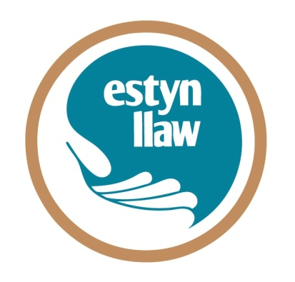

Meddwl ’Mlaen: Y Gymraeg, Iechyd Meddwl a’r 3ydd Sector
Thinking Ahead: Welsh language, Mental Health and the 3rd Sector

9.30am-1pm- 12.3.15
Y Mwnt, CAVS – Caerfyrddin / Carmarthen

Ffurflen Gofrestru Registration Form

Enw / Name : ______________________________________________________________

Teitl Swydd / Job Title : ______________________________________________________

Cyfeiriad / Address : _________________________________________________________________________

_________________________________________________________________________

Ffôn / Tel : ________________________________________________________________

e-bost / e-mail : ____________________________________________________________

Anfonwch anfoneb at fy sefydliad am y swm canlynol:
Please invoice my organisation for the following sum:
£30 (+TAW / VAT) tan / untill 16/2/15
£35 (+TAW / VAT) ar ôl / after 16/2/15
Rhif archeb / Order number : _________________
Cyfeiriad ar gyfer anfoneb (os yn wahanol i’r uchod)
Address for invoice (if different from above) _______________________________
________________________________________________________________________

_________________________________________________________________________

neu / or
Taliad BACS (gan nodi eich enw)
BACS paymaent (stateing your name)

Enw’r cyfri: Iaith Cyf Rhif: 47750952 Cod didoli: 54 – 10 – 26
Account Name Account number Sort Code:

Unrhyw ofynion (e.e. deiat, mynediad, gallu i symud, a.y.b.)
Any other requirements (e.g. dietary,access, mobility, etc.)

___________________________________________________________________

Byddaf angen offer cyfieithu o’r Gymraeg i’r Saesneg
I’ll need Welsh to English translation facilities

Dychwelwch at / Please return to:
kelly.davies@iaith.eu
(01239 711668) kelly.davies@iaith.eu www.estynllaw.org
Polisi Canslo
- Os oes rhaid i IAITH ganslo achlysur am unrhyw reswm, byddwch yn derbyn ad-daliad llawn.
- Dim ond yn ysgrifenedig neu drwy e-bost y gall cyfranogwyr ganslo archeb am le.
- Codir y ffioedd canlynol ar gyfranogwyr sy’n canslo archeb:
  - 6 - 15 diwrnod gwaith cyn yr achlysur: Codir 50% o’r gost
  - 5 diwrnod gwaith neu lai cyn yr achlysur (neu fethu â mynychu): Codir 100% o’r gost .

Cancellation Policy
- If IAITH has to cancel an event for any reason, participants will receive a full refund.
- We can only accept cancellations by post or e-mail.
- The following fees will apply in the event of participants cancelling:
- 6 - 15 working days prior to the event: 50% of course fee
- 5 working days or less prior to the event (or non-attendance): 100% of course fee.

Polisi Preifatrwydd IAITH: Mae IAITH yn parchu eich hawl i breifatrwydd, a bydd unrhyw wybodaeth neu fanylion rydych yn dewis eu darparu drwy gyfrwng y ffurflen hon yn cael eu cadw yn swyddfa’r ganolfan, ac yn cael eu defnyddio i alluogi IAITH i gyflwyno gwybodaeth am y gwasanaethau rydych wedi mynegi diddordeb ynddynt, neu unrhyw wasanaethau perthnasol rydym yn teimlo a fydd o ddiddordeb i chi. Drwy ddarparu eich manylion cyswllt, rydych yn cydsynio i ni eu defnyddio i’r dibenion a nodir uchod. Ni fyddwn yn trosglwyddo eich manylion i unrhyw drydydd parti.

Mae IAITH wedi cofrestru dan Ddeddf Diogelu Data 1998.

IAITH’s Privacy Policy: IAITH respects your right to privacy, and any information or details you choose to provide through this form will be kept in IAITH’s office, and will be used to enable IAITH to provide information about services in which you have expressed an interest or relevant services which we feel may be of interest to you. By providing your contact details, you consent to us using it for the purposes outlined above. We will not pass on your information to any third party.

IAITH is registered under the Data Protection Act 1998

